**Constructions**

# To Construct an Angle Equal to a Given Angle

Given: Any POQ and a point A

Required: To construct an angle at A equal to POQ Steps of Construction:

1. With O as centre and any (suitable) radius, draw an arc to meet OP at R and OQ at S.
2. Through A draw a line AB.
3. Taking A as centre and same radius (as in step 1), draw an arc to meet AB at D.
4. Measure the segment RS with compasses.
5. With D as centre and radius equal to RS, draw an arc to meet the previous arc at E.
6. Join AE and produce it to C, then BAC is the required angle equal to POQ.

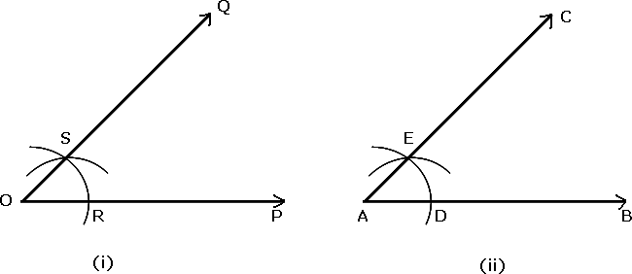

# To Bisect a Given Angle

Given: Any POQ Required: To bisect POQ. Steps of Construction:

1. With O as centre and any (suitable) radius, draw an arc to meet OP at R and OQ at S.
2. With R as centre and radius more than half of RS, draw an arc. Also, with S as centre and same radius draw another arc to meet the previous arc at T.
3. Join OT and produce it, then OT is the required bisector of POQ.

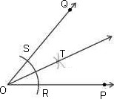

# To Construct some Specific Angles

## To construct an angle of 60°

Steps of Construction:

1. Draw any line OP.
2. With O as centre and any suitable radius, draw an arc to meet OP at R.
3. With R as centre and same radius (as in step 2), draw an arc to meet the previous arc at S.
4. Join OS and produce it to Q, then POQ = 60°.

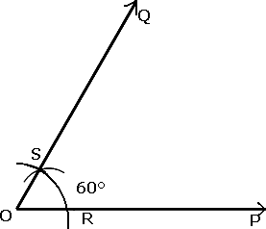

## To construct an angle of 30°

Steps of Construction

1. Construct POQ = 60°.
2. Bisect POQ. Let OT be the bisector of POQ, then POT = 30°

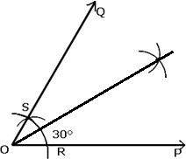

## To construct an angle of 120°

Steps of Construction:

1. Draw any line OP.
2. With O as centre and any suitable radius, draw an arc to meet OP at R.
3. With R as centre and same radius (as in step 2), draw an arc to meet the previous arc at T. With T as centre and same radius, draw another arc to cut the first arc at S.
4. Join OS and produce it to Q, then POQ = 120°.

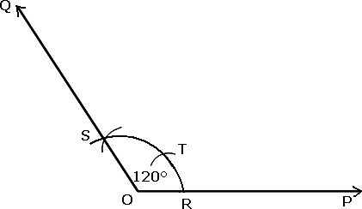

## To construct an angle of 90°

Steps of Construction:

1. Construct POQ = 60°
2. Construct POV = 120°.
3. Bisect QOV. Let OU be the bisector of QOV, then POU = 90°.

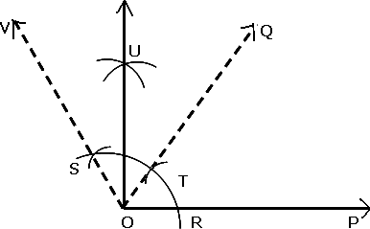

## To construct an angle of 45°

Steps of Construction:

1. Construct AOP = 90°.
2. Bisect AOP.

Let OQ be the bisector of AOP, then AOQ = 45°

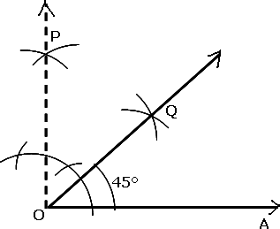

# To Draw a Perpendicular Bisector of a Line Segment

Given: Any line segment PQ.

Required: To draw a perpendicular bisector of line segment PQ. Steps of Construction:

1. With P as centre, take a length greater than half of PQ and draw arcs one on each side of PQ.
2. With Q as centre and same radius (as in step 1), draw two arcs on each side of PQ cutting the previous arcs at A and B.
3. 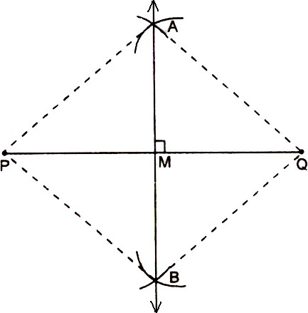Join AB to meet PQ at M, then AB bisects PQ at M, and is perpendicular to PQ, Thus, AB is the required perpendicular bisector of PQ.

# Construction of a Triangle, given its Base, sum of the other two sides and one Base Angle

To construct ΔABC in which base BC, B and sum AC + AB of other two sides are given. Steps of construction:

* 1. Draw the base BC and at the point B, make an angle, say XBC equal to the given angle.
  2. Cut a line segment BD = AC + AB from the ray BX.
  3. Join DC and make angle DCY equal to angle BDC.
  4. Let CY intersect BX at A.
  5. ABC is the required triangle.

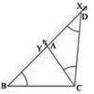

## Alternate Method

Steps of construction:

1. Draw the base BC and at the point B, make an angle, say XBC equal to the given angle.
2. Cut a line segment BD = AC + AB from the ray BX.
3. Draw perpendicular bisector PQ of CD to intersect BD at a point A. Join AC. ABC is the required triangle.

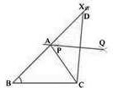

# Construction of a Triangle, given its Base, difference of the other two sides and one Base Angle

To construct ΔABC when the base BC, a base angle B and the difference of other two sides AB - AC or AC - AB are given.

**Case 1**: When AB > AC and AB - AC is given Steps of construction:

* 1. Draw the base BC and at point B make an angle say XBC equal to the given angle.
  2. Cut the line segment BD equal to AB - AC from ray BX.
  3. Join DC and draw the perpendicular bisector, say PQ of DC. Let it intersect BX at a point A. Join AC Then, ABC is the required triangle.

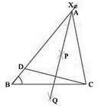

**Case 1**: When AB < AC and AC - AB is given Steps of Construction:

* + 1. Draw the base BC and at point B make an angle say XBC equal to the given angle.
    2. Cut a line segment BD equal to AC - AB from the line BX extended on opposite side of line segment BC.
    3. Join DC and draw the perpendicular bisector, say PQ of DC.
    4. Let PQ intersect BX at A. Join AC. Then, ABC is the required triangle.

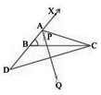

# Construction of a Triangle of given Perimeter and Base Angles

To construct a triangle ABC, when its perimeter, AB + BC + CA, and two base angles, B and C, are given.

Steps of Construction:

* + - 1. Draw a line segment, say XY = BC + CA + AB.
      2. Construct LXY = B and MYX = C.
      3. Draw the bisectors of LXY and MYX. Let these bisectors intersect at point A
      4. Draw a perpendicular bisector PQ of AX and RS of AY.
      5. Let PQ intersect XY at B and RS intersect XY at C.
      6. Join AB and AC. Then, ABC is the required triangle.

